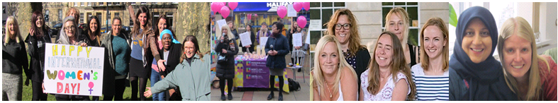
Female* IDVA
(North Somerset Services)

We have a rewarding opportunity available for a Female IDVA to join our team based across North Somerset. You will join us on full time, permanent basis, working 37.5 hours per week including participation in out of hours telephone on-call rota and some evenings and Saturdays. In return, you will receive a competitive salary of £22,183 per annum (not IDVA qualified) or £23,541 (IDVA qualified or gaining the qualifications) plus benefits.

Established in 1999, Next Link is the leading provider of domestic abuse services to women and children in Bristol, South Gloucestershire and North Somerset. At Next Link we are committed to providing holistic, empowering and personalised support and advocacy to women and children experiencing domestic abuse. With a focus on survivor’s safety and recovery; we believe the provision of flexible support tailored to survivor’s needs can be transforming, helping to maximise independence and se lf-determination so survivors can make informed choices.

In return for joining us, we will offer you:

- Up to 30 days annual leave (depending on length of service)
- 3 extra holidays including International Women’s Day
- Excellent development and training opportunities
- Employer pension contribution (minimum 5% of your gross salary)
- Mindful Employer Plus Scheme
- Cycle to Work Scheme
- Long Service Awards
- Wellness Awards

About the role:

This post will be based within Next Link Domestic abuse services providing outreach, and community-based support to high risk victims across North Somerset. Working closely with the Lighthouse, One Front Door and MARAC to provide co-ordinated package of emotional and practical support, advice and advocacy to female or male high-risk survivors of domestic violence and their children,

The role involves empowering high-risk survivors to increase their options, make positive choices/decisions, increase their confidence, safety and recovery.

Key duties and responsibilities of our Female IDVA:

- To carry out risk assessments including DASH, co-produce safety plans with the service user regularly review the plans, enabling survivors to assess and manage risk to their own and their children’s safety. Amend plans as appropriate when circumstances change and attend the MARAC and refer service users when appropriate.
- Carry out needs assessments which effectively establish the support needs of individuals and families and enable support to be offered as quickly as possible. Respond flexibly as the individuals or family’s needs and risks change
- Promote the service through building positive relationships with the Police, Lighthouse, current and potential referrers and service users to ensure a steady flow of appropriate referrals.

- When appropriate, using our established protocols, make referrals to Addaction for Substance Misuse support services and AWP Mental Health services for a mental health assessment
- Liaise closely with applicant and referral agencies and keep informed of progress and outcome of their referral/assessment.

What we are looking for in our ideal Female IDVA:

- Be IDVA qualified or working towards qualifications
- Proven experience of working with women / men and children who have survived domestic abuse
- Extensive experience of supporting high risk victims
- Experience working with the police, Lighthouse and MARAC
- Experience of undertaking individual assessments including DASH risk assessments and developing and delivering safety and support plans.
- Experience of co-producing short- and longer-term risk management, safety planning and support with survivors and their children experiencing Domestic Abuse
- A full driving licence and access to transport

Closing date: 9am Monday 12th October 2020.
Interview date: WC 12th October 2020.

How to apply:

Please apply now to join us as our Female IDVA (North Somerset) and contribute to the valuable work Next Link and its wider services, delivering hope and support to survivors of domestic violence and abuse.

www.nextlinkhousing.co.uk HR.Enquiries@missinglinkhousing.co.uk

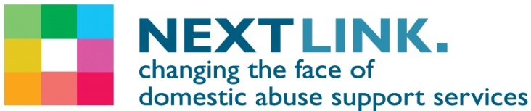
Next Link is committed to safeguarding and promoting the welfare of children, young people and adults at risk of abuse, and expects all staff and volunteers to share this commitment. Next Link is committed to Equal Opportunities. *Due to the specific requirements of this role, this post is exempt under the Equality Act (2010), Part 1, Schedule 9 (Genuine Occupational Requirement) Next Link is part of Missing Link Housing.

